****

**Business Plan**

**Business Plan**

Index

[1. Corporate 7](#_Toc414612856)

[2. Market Analysis 8](#_Toc414612857)

[2.1 Market segment 13](#_Toc414612858)

[2.2 Main Competitors 14](#_Toc414612859)

[3. Marketing and Sales 16](#_Toc414612860)

[3.1 Marketing Strategies 17](#_Toc414612861)

[3.2 Strength and Weakness (SWOT Analysis) 18](#_Toc414612862)

[4. Offered service 21](#_Toc414612863)

[5. Management and Team 22](#_Toc414612864)

[6. Development and Financial needs 24](#_Toc414612865)

[7. Economic and Financial Areas 26](#_Toc414612866)

**EXECUTIVE SUMMARY**

1. **Company**

**Rumorants** takes its steps a couple of years ago, in 2012, from the mind of Matteo Di Tucci, which felt the need to design a new way to communicate among people. The market was already full of chat mobile apps and worldwide linking technologies, but examining and discussing this topic with professionals, the idea has been developed and adapted to become a new virtual place where retailers and consumers may meet. A market with new rules that fits micro, small and medium-sized enterprises needs and with a strong increase of advertising efficiency.

1. **Project idea**

Traders, tired of the high cost and poor results from investments in flyers and newspaper advertisements have embraced new technologies in complete autonomy, but once more the results aren’t coming as expected; for sure investments decreased, but without boosting actual sales.

All the clues acquired investigating the market lead to a strong conclusion: the market is ready for **Rumorants**. Traders and consumers are trying to find the best way to employ available technology in order to maximize advertising efficiency and **Rumorants** is the best solution to achieve that goal.

****

Rumorants strength is that all project has been lead by the will to optimize communication among people, transferring this approach to local advertising the result was exceptional. Finally retailers and consumers will have a tool that allow them to communicate worldwide and with two main indisputable advantages:

1. Retailer’s will reach only truly interested consumers;
2. Consumers will ask for ads and will not be overwhelmed by them.

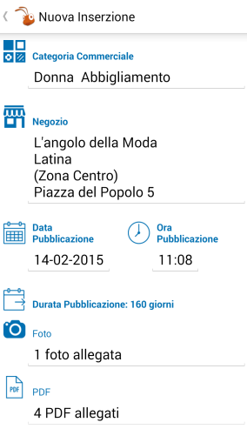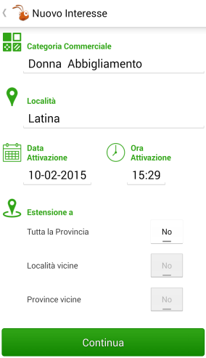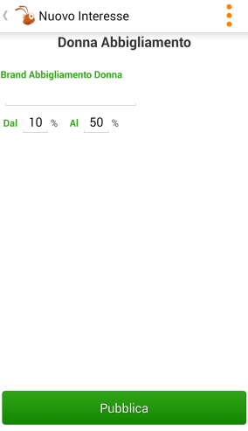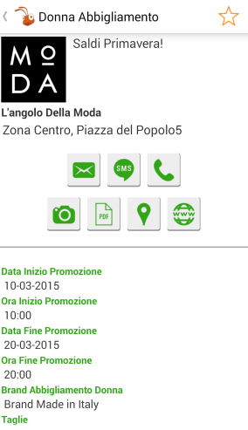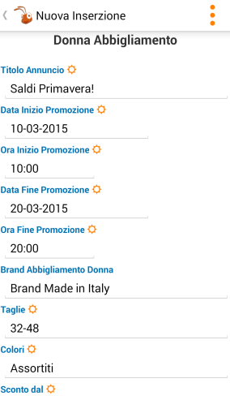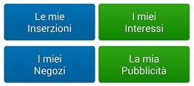

1. **Market**

The 41% of the Italian population has a mobile device and 92% of them use these devices to acquire information about products. These figures leaves no room for doubt; to widespread Rumorants service the way is to develop a mobile app at least for the main three competitors of app market: Apple Store, Google Play and Microsoft Store

Moreover it’s highly relevant to consider also the download volumes of the available apps that are about 50 billions for Google Play and 75 billions for App Store. In this scenario these three mobile stores become not only our main means of distribution, but also our key partner and key resources.

The analysis carried out on potential competitors highlighted the uniqueness of **Rumorants**, which encloses a set of advantages unidentified in any other existing product, both for retailers and consumers.

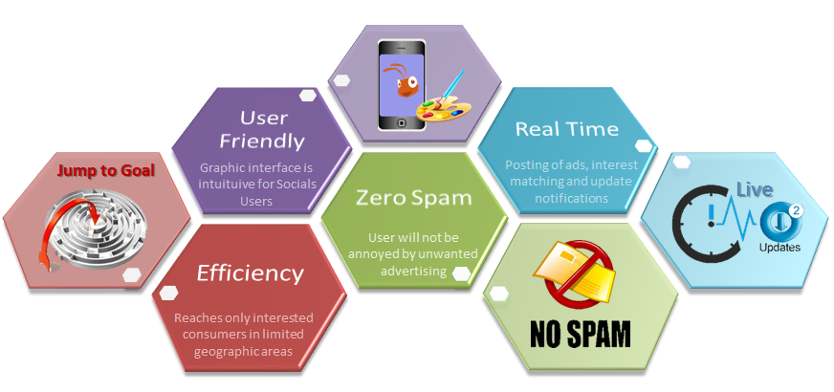

The real challenge is played on the field, **Rumorants** has to overcome the distrust against non-traditional tools, result from years of micro, small and medium enterprises failures in attempting to grow.

1. **Management & Team**

Once **Rumorants** idea has been shared and agreed; the creator of the service and his father, owner of the consulting company Able One Systems, organized a team of people with the aim of creating a pilot intended to test and receive feedbacks from a pool of real users.

The skills and experience of each member of the team reflect the exact requirements to achieve this goal:

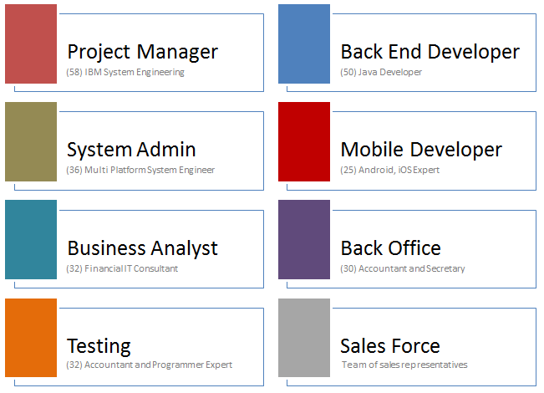

Once the app will reach the expected distribution the organization will count about 20 employees, managed by 3 Board resources.

The responsible of each Area has been chosen for having established suitable skills and work experience mentioned in the chapter of this prospect:

* System Manager – Ing. Cosmo Di Tucci
* Application Manager – Ing. Matteo Di Tucci
* Finance & Marketing Manager – Dott. Mauro Madeddu

1. **Finance**

The detailed analysis of the market segment in which **Rumorants** will operate allowed to evaluate forecasts and produce economical and financial prospects, although important items are still missing so all results and components that determine them are therefore subject to considerable variation depending on many factors.





# **Corporate**

**Rumorants** takes its steps a couple of years ago, in 2012, from the mind of Matteo Di Tucci, which felt the need to design a new way to communicate among people. The market was already full of chat mobile apps and worldwide linking technologies, but he anyway shared his project ‘Ants’ with his father, Cosmo Di Tucci (owner of Able One Systems S.r.l. Consulting Company), and with a team of professionals in different areas.

The original goal of ‘Ants’ was to share news, information, chats or whatever posted by users, with other users linked in the same limited geographic area. A new Hi-Tech ‘word of mouth’ with the opportunity to easily involve unknown people and quickly spread communication in a certain district and neighboring.

Examining and discussing this topic with professionals, the idea has been developed and adapted to **Rumorants**. ‘Ants’ was in fact the perfect ground on which structuring a new virtual place where retailers and consumers may meet. A market with new rules that fits micro, small and medium-sized enterprises needs and with a strong increase of advertising efficiency.

On this basis and considering global market trend, **Rumorants** team signed an agreement; started developing a mobile app and it is now ready to become a start-up company and a widespread mobile app among users.

# **Market Analysis**

**Rumorants** has been thought and designed to be distributed through the three main platforms of mobile apps stores: Google Play Store, Apple App Store, and Microsoft Windows Store. Worldwide marketing and trading companies already developed and delivered buy&sell mobile apps in the past years, but in despite of the strong competition detected, **Rumorants** target is one of a kind and represents an important innovation.

Trade globalization moved jointly with communication means and e-commerce seems to be not only our recent past and our present but also our future. E-commerce phenomenon influenced governmental regulation and revolutionized markets and retailers behaviors. Moreover, different economics theories and forecasts where processed and discussed about e-commerce, but it is difficult to disagree with the following extract from an article published by ‘The Economist’ in July, the 2010:

*“Economists have theorized that e-commerce ought to lead to intensified price competition, as it increases consumers' ability to gather information about products and prices” … “The lone exception to this pattern has been the very smallest category of bookseller, shops with between one and four employees, which appear to have withstood the trend.”*

(The Economist. 3–9 July 2010. p. 78 – Economics focus: “The click and the dead”)

Experiencing the Italian trade market fragmentation, micro, small and medium-sized enterprises cannot be considered as a negligible detail; instead, they increase their importance extending the analyzed area to the whole ‘old-country’ as confirmed by the European Commission:

*“Micro, small and medium-sized enterprises (SMEs) are the engine of the European economy. They are an essential source of jobs, create entrepreneurial spirit and innovation in the EU and are thus crucial for fostering competitiveness and employment”.*

(Gunter Verheugen, responsible of the European Commission for Enterprise and Industry (2006). The new SME definition - Intro)

The most part of these enterprises has not the opportunity to access the e-commerce services and advantages. For this reason, they consider local advertising the main instrument to publicize events, products and offers in a certain geographic area.

In his speech 'The SMEs that communicates' Alberto Dal Sasso, Director of Nielsen Media division, explained that micro, small and medium-sized enterprises generate more than a fifth of total investment: 12,231 businesses face a cost of 1.2 billion of euros, with an average spending of 100 thousand euro.

In an economic recession period, just like the current one, the advertising cost is prohibitive for small and medium-sized Italian companies which are the backbone of our economy. They are seen therefore also precluded to access media and see its potential decrease in the market, because of their limited ability to interact with their target. It is a paradoxical situation, determined essentially by the very high cost of ownership of the media and therefore their need to collect a lot of publicity, a fact that increases the crowding and requires large budgets to gain visibility.

An example of the consequences of this situation is well represented by the lower yields detected in the Print Advertising in the last years, but going local doesn’t mean avoiding the Internet anymore. Internet advertising, which was traditionally the domain of geographically unrestricted firms that benefited from its global reach, is now being embraced by local businesses targeting a local audience.

In fact, by 2015, local online ad spending will make up nearly one-quarter of all advertising by local businesses, according to BIA/Kelsey, [eMarketer Digital Intelligence](http://www.emarketer.com/Article.aspx?R=1008315" \t "_blank) reports. Within local online and interactive advertising, Borrell Associates estimates that by 2015, two-thirds will come from mobile [ads on tablets](http://www.businessnewsdaily.com/685-eye-candy-wins-clicks-of-tablet-users-research-says.html), smartphones and GPS-enabled laptops.

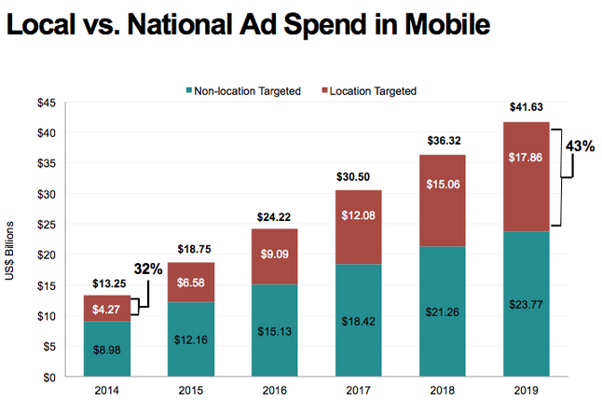

Currently, small businesses seeking to reach a local audience have focused on localized search engine marketing, such as Google Places and Yahoo! Local,  Going forward, however, local small businesses are also staking out more territory on social media, with 70 percent already using Facebook, 58 percent using LinkedIn and nearly 40 percent using Twitter. Here’s how business owners ranked their overall [local advertising](http://www.businessnewsdaily.com/773-manta-an-online-marketplace-for-small-business.html) in terms of effectiveness:

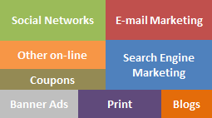

Traders, tired of the high cost and poor results from investments in flyers and newspaper advertisements have embraced new technologies in complete autonomy, hoping at least to reach a wider number of consumers and certainly with a lower cost.

Mailing lists, Web pages, socials and many mobile apps are full of ads; retailers are trying every possible means to improve the way to reach as many as possible consumers, but once more the results aren’t coming as expected; for sure investments decreased, but without boosting actual sales.

All these clues acquired investigating the market lead to a strong conclusion: **the market is ready for Rumorants**. Traders and consumers are trying to find the best way to employ available technology in order to maximize advertising efficiency and Rumorants is the best solution to achieve that goal.

****

Rumorants strength is that all project has been lead by the will to optimize communication among people, transferring this approach to local advertising the result was exceptional. Finally retailers and consumers will have a tool that allow them to communicate worldwide and with two main indisputable advantages: retailer’s will reach only truly interested consumers; consumers will ask for ads and will not be overwhelmed by them.

## Market segment

**Rumorants** represents an innovative and simple mobile instrument that allows micro, small and medium-sized retailers to advertise their products and quickly reach potential customers through a new channel based on existing technologies.

The goal is not indeed to provide a service which takes care of all transaction’s aspects including invoicing, payments and delivery of goods, as already existing on the web store. **Rumorants** has the ambition to become the reference tool in the advertising market. The best place where retailers and customers may meet.

Currently most of micro enterprises, perhaps having access to technologies, doesn’t have the opportunity in terms of time and costs to set up and maintain a shop online and still use traditional advertising means, such as: leaflets, newspaper ads, banners and advertising on local media.

In the United States of America each consumer receives an average of 2.000 daily advertise proposal, which decreases to about 1.000 in the main European countries. The overcrowding advertises issue is not so new, in 1759, Samuel Johnson, already wrote on ‘The Universal Chronicle’:

*“Advertisements are now so numerous, that they are very negligently perused, and it is, therefore become necessary to gain attention by magnificence of promises, and with eloquence sometimes sublime and sometimes pathetic”.*

(Samuel Johnson, Idler n° 40, 20th January 1759 – The Universal Chronicle, London)

It is not surprising, therefore, that consumers are looking for ways to avoid advertising. What we do today with the remote control on television existed long before the electronic media could make it easier. The human eye is able to jump almost instinctively ads in a newspaper or in a magazine. Consumers are today experts in filtering information they receive, a cursory examination of advertising is enough to decide which message will be listened and processed and which instead will be ignored ruthlessly.

Authors wrote down books and theories to encourage creative efforts in advertising, but small businesses already facing strong competition from larger business cannot afford to challenge also on commercials. Analyzing this juncture, **Rumorants** shows its greatest strength: reverse the advertising approach. The consumer seeks for the ad. Micro, small and medium-sized enterprises will have a virtual place where offering their products and consumers will access the same place searching and filtering for what they need without receiving useless information.

## Main Competitors

**Rumorants** target is not to interfere in negotiations between the parties, but to provide a simple, intuitive, immediate application where buyers and sellers may meet and then contact themselves to conclude their trade. The market niche is not approached to gain on transactions as eBay or amazon, but to avoid smaller companies to fight their daily expensive battle to reach truly potential customers and to avoid consumers to be drowned by sterile and noisy advertising.

The market is full of potential competitors, removing the last doubts about the real need to offer more available alternatives in order to advertise the products of micro, small and medium-sized enterprises. One of the most widespread techniques is to translate the flyer paper in a digital flyer:



DoveConviene is the Italian leader platform on which 5 millions of Italians gets ready to go shopping in stores near home. It is a digital newsstand that provides flyers and catalogs of major retailers and brands in each category to consumers in the stores area. Funded in 2012 it is a crucial complement to the distribution of flyer papers.

**Strength:** easy to use, provides marketing statistics and reports, newsletter on consumers request

**Weakness:** payment for each visualization, no ads in real time



PromoQui is localized saving, the point of contact between the retailer and its potential customers. The opportunity to find the same item at a discounted price is the reason of the increasing number of people that enquires online before buying. PromoQui offers to have the availability of real-time flyers and offers produced by shops around you, updated frequently: over 1.000 new flyers every week; more then 60.000 points of sale; 3 millions of web users.

**Strength:** provides direction to reach the store, notifications on updates of interests, real-time offers

**Weakness:** monthlypayment on subscription, very articulated structure



Volantino Digitale has the purpose to provide an advertising product that combines the effectiveness of a professional flyer to the power of the Web as a means of distribution, and that ensures delivery and information on the consumers that read it.

**Strength:** widespread the flyer through many websites

**Weakness:** doesn’t ensure to reach real-time interested consumers, no notifications on interests updates

DoveConviene, PromoQui and Volantino Digitale are examples of technologies applied to traditional advertising tools. The advantage for the retailer is to extend the pool of people reached; and for the consumers is to avoid being overwhelmed by paper and have a place where quickly find and compare different flyers offers.

As we recognize the improvements made by these web services, **Rumorants** stepped forward with real-time ads addressed only to interested customers. A real solution that avoids the businesses costs of mass advertising, which often does not draw economical benefits, and save consumers from all annoying and invasive commercials.

# **Marketing and Sales**

The 41% of the Italian population has a mobile device and 92% of them use these devices to acquire information about products. These figures leaves no room for doubt; to widespread **Rumorants** service the way is to develop a mobile app at least for the main three competitors of app market:



\*Statistics are referred to the latest available updates (Google, July 2013; Apple, June 2014; Windows Store, August 2014)

Moreover it’s highly relevant to consider also the download volumes of the available apps that are about 50 billions for Google Play and 75 billions for App Store. In this scenario these three mobile stores become not only our main means of distribution, but also our key partner and key resources.

## Marketing Strategies

**Rumorants**, like any other startup, by definition has the primary objective to search for a repeatable and scalable business model. In this phase of development and market research it is important to plan an initial marketing strategy that allows to start on the right foot and to build a solid foundation for the subsequent phases.

The app, already developed and released on Google Play for Android platform, needs to be distributed and used by people which will account for the project an added value in terms of testing and feedbacks. Since the first draft of the app, many suggestions were provided by users both in terms of graphic interface and in terms of improvement of process details.

Currently **Rumorants** team is working in parallel on two main aspects:

* developing a version to be released in the Apple App Store for iOS platform
* offering free use of the product to retailers and consumers in a limited geographic area, asking them to try this solution and provide feedbacks

on this last and particularly relevant item, the applied strategies is to propose the app through commercial agents with the goal to reach at least 100 active retailers and to widespread the app among consumers with the evergreen word of mouth and the more recent use of socials means.

## Strength and Weakness (SWOT Analysis)

The analysis carried out on potential competitors highlighted the uniqueness of **Rumorants**, which encloses a set of advantages unidentified in any other existing product, both for retailers and consumers.



On the other hand this new solution has to face a particular market niche. Currently micro, small and medium-sized enterprises, in fact, aren’t having the expected results by advertising. Advertise a product represents high costs, waste of time and very low Return On Investments. The hardest obstacle to overcome is to break the wall of indifference of disillusioned people.

Browsing web pages looking for advice to help grow business volumes is full of marketing decalogues; laws to be respected slavishly, representing the scientific formula solver of all business problems, regardless of type, industry, size and each unique characteristics. These theories have been popular for years and many companies have tried to follow them hopefully, unfortunately often without any real economic return.

*“Firm size within an industry often varies all the way from single person firms to large firms. Naturally, this leads many entrepreneurs to aspire to grow, but if special managerial talent is necessary to succeed at larger scales, how do individuals learn whether they have what it takes to manage a larger enterprise? We start off with a model that incorporates heterogeneity in entrepreneurial talent, unobserved to all, to help understand the experimentation and learning process for micro entrepreneurs about their optimal size. We show how financial and managerial capital market imperfections can impede experimentation  and thus limit learning about the profitability of alternative ways of organizing one’s business. The assumptions and the model generate a simple prediction: on average most businesses will not, in fact, do better after attempting to grow, but a few will succeed.”*

(D. Karlan, R. Knight, C. Udry (2012) – “Hoping to win, expected to Lose. Theory and lessons on micro enterprise development”)

Probably the worst consequence of these micro and macro failures is that companies are not only back to where they started regressing, but have obviously lost confidence in marketing, advertising and in any new or different tool that prospects to provide them improvement opportunities and guaranteed financial returns.

*“We show how financial and managerial constraints impede experimentation, and thus limit learning about the profitability of investments. Imperfect information about one’s own type, but willingness to experiment to learn one’s type, leads to short run negative expected returns to investments, with some outliers succeeding. We find in an experiment that entrepreneurs invest randomized grants of cash, and adopt advice from randomized grants of consulting services, but both lead to lower profits on average. In the long run, they revert back to their prior scale of operations.”*

(D. Karlan, R. Knight, C. Udry (2012) – “Hoping to win, expected to Lose. Theory and lessons on micro enterprise development”)

The SWOT matrix graphically helps to take the sums of what above written:

The matrix helps to separate internal and external components. The firsts, strengths and weaknesses, are typical of the application, of how it has been developed and structured. Strength and guidance provides guidance on the way forward highlighting what has been well done and what needs to be done next.

For sure the team is already working on developing and releasing the application on all the major platforms; It will wait feedbacks instead, to assess whether the absence of a complete intermediation in the sale consists in a concrete weakness, considering the target for which the application has been developed.

The real challenge is played on the external components, on one side Rumorants with its uniqueness has the opportunity to become a leader in the segment with a widespread distribution in Italy and abroad; on the other side it has to overcome the distrust against non-traditional tools, result from years of micro, small and medium enterprises failures in attempting to grow.

# **Offered service**

**Rumorants** born from the idea of bringing together consumers and companies, allowing both to benefit from advertising. Currently the small and medium enterprises cannot access to incisive way to advertise their product and services because of the high cost and time needed for a very minimum return of investing.

Our mobile service differs from any other product, it resets the time to advertise. The release of ads becomes instantaneous, just as posting on socials. Moreover it strongly reduces the cost of an advertising campaign.

The tool also provides the immediate attainment of only interested consumers, in specific geographic areas reached by their own affairs. Consumers are for sure interested to the point of having asked themselves the advertising of that product and at the same time they freely receive instantly and with continuous updates any ad that matches their needs, without having to search each time and without any spam.

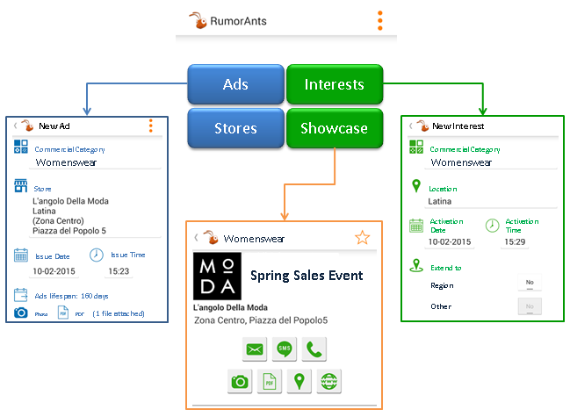The application performs automatic updates. Every few minutes it checks all Interests and Ads posted by users and verifies matching. All the matched Ads will be directly shown on the Showcase and notified through the mobile platform features.

# **Management and Team**

Once **Rumorants** idea has been shared and agreed; the creator of the service and his father, owner of the consulting company Able One Systems, organized a team of people with the aim of creating a pilot intended to test and receive feedbacks from a pool of real users.

The skills and experience of each member of the team reflect the exact requirements to achieve this goal:



The Project Manager is an electronic engineer grew in IBM, which consolidated his experiences becoming owner of a company that offers consulting service to major Italian and Multinationals companies.

The Back End Developer is a Senior Java Developer that can boast more then twenty years of experience in Telcos.

The System Admin has also almost twenty years of experience as System Administrator both on Linux and Windows Platforms in nationwide and multinational environments.

The Mobile Developer Is a graduate in computer engineering, with special interest in multiplatform mobile development.

The Business Analyst has a degree in economics and a background that crosses from Finance Accounting and IT software development in multinational environment.

Back Office, Testing and Sales Force completes the picture of a team design to fit perfectly project needs.

# **Development and Financial needs**

The achievement of the current state of Rumorants project is the result of investments in terms of time and economic resources. One year and a half has passed since the first meetings; about ten people has been involved during the different phases of development. The below graph provides an idea of the effort made by each area:

After month of hard work and about 370,000€ invested Rumorants app is already available in Play Store for Android Platform and soon also available in App Store for iOS mobile devices. The service has been offered to traders in Latina and the goal is to reach at least 100 of active retailers using Rumorants and providing feedbacks.

The Current Hardware Architecture is defined as following picture:

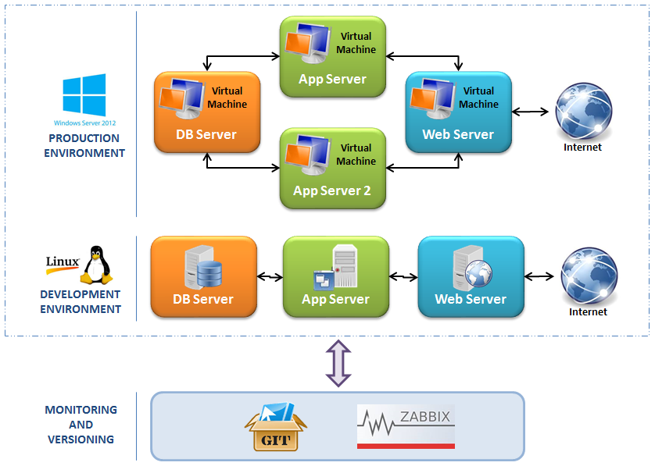

The next step of growth requires a hardware upgrade and an increase of monthly costs, including the set-up of an helpdesk service to provide a fast support to Rumorants customers. A first estimate shows a one-time need of 50,000€ for architectural hardware upgrade; and monthly costs that increases of about 4,000€ for monthly ISP advanced services and about 10,000€ for help-desk resources.

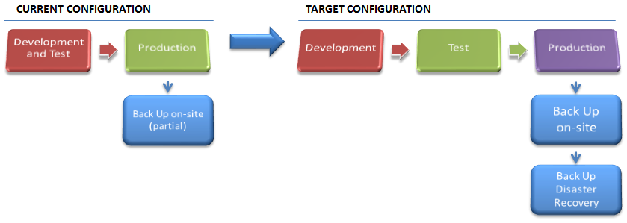

# **Economic and Financial Areas**

**Rumorants** is a mobile app and as such the chance of profit are varied. Probably the main revenue stream is given by advertising that can be proposed to users during the service. In the eyes of **Rumorants** founders, the main advantage for both retailers and consumers using this app is that no one receives unwanted ads, so the management decided to exclude the opportunity to acquire revenues from third companies banner ads.

The other three available ways to earn from the service are:

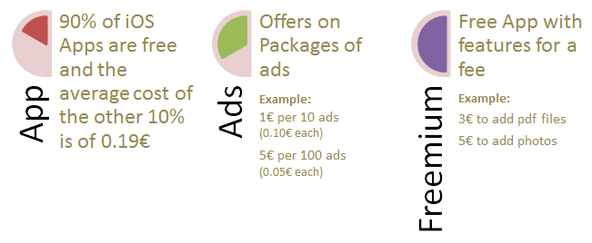

The exact strategy will be defined in detail considering the results and feedbacks from the pilot distributed to over a thousand users; it could be a mix of all the above mentioned available revenues streams and its conceivable that the exact definition may be delegated to a possible partner in charge of sales and marketing area.

In addition, a significant source of revenue comes from ancillary services. At full capacity the application will record the daily tastes and preferences of consumers by providing direct and useful market information that can be shared both with retailers operating in different sectors and with companies that deal with market databases and statistics.

In order to provide an idea of revenues returns from the project, it’s possible to hypothetical draw the following scenario:

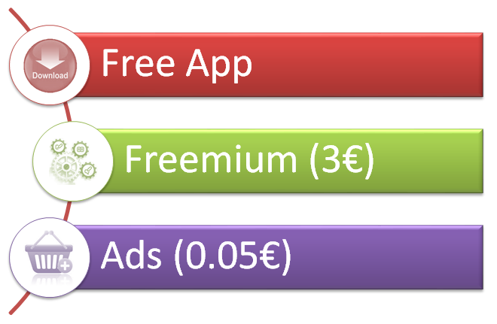

The number of **Rumorants** users increases during the years as the app spreads among the nation:

* 100,000 Users within 2016
* 500,000 Users within 2017
* 2,500,000 Users within 2018

Retailers will be about the 10% of users and only the 7% of them will buy additional features. Each retail will post about 100 ads each month for a cost of 5€. These figures can be summarized as follows:



In order to evaluate the feasibility and profitability of extending the project to reach nationwide users, is equally important to make a careful estimate of the costs required to run the service. The mobile app has no significant variable costs, so the analysis has been detailed on three different groups of fixed costs, as follows:



Some of the listed costs are periodical and some others ore one-time amortizable costs. This aspect has been appropriately considered in the drafting of balance sheets forecasts.

Forecasts of the next three years of economical situation:



The detailed analysis of the market segment in which **Rumorants** will operate allowed to evaluate forecasts and produce economical and financial prospects, although important items are still missing so all results and components that determine them are therefore subject to considerable variation depending on many factors:

With the scope to provide an idea of project potentials three cases have been studied to define a range of possible cash flow forecasts. The key difference among worse, base and best case is the number of active users reached by the application.





